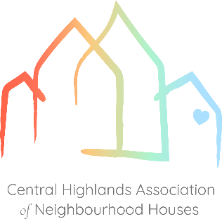
GOvernance Materials Pack

The following documentation, created by Central Highlands Association of Neighbourhood Houses (CHANH), provides members Board of Governance (or Committees of Management) with resources for good practice. Your Neighbourhood House Board may choose to adopt the whole pack or individual documents which suit their needs.

Each of the templates or guidance resources provided can be used or modified to suit the requirements of the house, whilst providing an efficient and effective approach to meet the key requirements of governance.

The pack is comprised of both regular meeting related documents and annual documents, and is designed with new and inexperienced committee members in mind.

The governance pack does not constitute policy; rather, it is a set of procedures designed to inform and support, or be adjusted to align with, the organisation's policies. While not a comprehensive set of documents, the governance pack provides core materials to support essential committee functions. Suggestions for additional templates to be included in the pack are welcome.

Any questions regarding use of this pack, its contents or other governance related queries can be directed to CHANH, on 0428 325 926 or networker@chanh.org.au.

Further information about Board responsibilities and approaches can be found at https://www.nhvic.org.au/governance, https://www.ourcommunity.com.au and http://boardconnect.com.au . Many thanks to the people behind these organisations for their expertise and willingness to share to support the work of neighbourhood houses.

